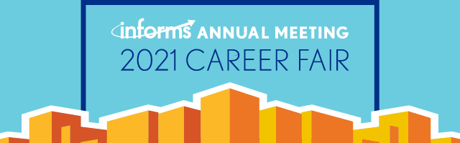
Requesting/Scheduling Interviews
The key to a successful career fair experience is to secure your interviews with potential employers prior to the event. Please review the information below to ensure that you have correctly scheduled interviews for positions you are interested in.
(Note – you will only be able to schedule the interviews with employers if you are both attending the 2021 INFORMS Annual Meeting and Career Fair.)
- Login to your career center account https://careercenter.informs.org/login – You will login with your username / password. Once logged in you will be on the “Overview” page.
- On the Overview page click the “Attend This Event” button to highlight your resume so recruiters can identify and contact you about interviews while attending the 2021 INFORMS Annual Meeting Career Fair.
- Click on the “Jobs” link at the top of the page.
- Check the box that states “Only show 2021 INFORMS Annual Meeting Career Fair jobs” – enter any additional search criteria – then click the “Search Jobs” button.
- Once you have located a position you are interested in, click on the title of the listing – then write a message to the employer, then add your documents.
- Carefully review the information that you have composed on the next page – if satisfied click the “Request Interview” button.
- Your interview request has now been sent to the employer. If the employer would like to schedule the interview, they will designate a location and time at the Anaheim Convention Center which you will see later in your “Messages” section on your “Overview” page – if you are good with the time, simply confirm and meet them at their table during the designated date/time.
If you have any questions or need assistance, please contact us at 888.491.8833 x 2736 or Robin.Kidwell@Naylor.com

